Practical
SUMMARY:-
In this practical, I studied different sorting methods and learned how they arrange numbers from smallest to largest.

Bubble Sort works by comparing nearby elements and swapping them when needed.
output
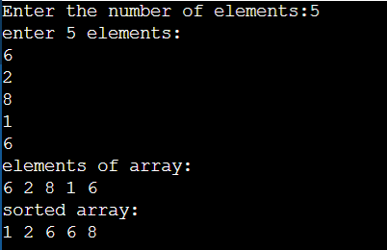

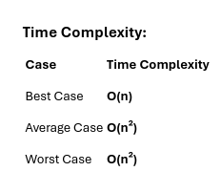

Selection Sort finds the smallest value and puts it in the correct place.
output
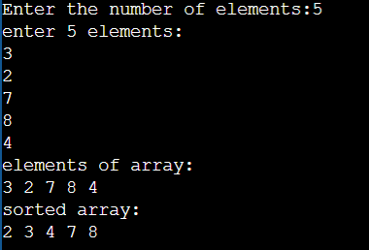

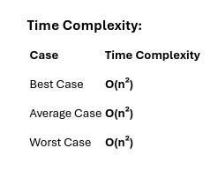

Insertion Sort takes one element at a time and inserts it into the right position in the sorted part of the list.
output
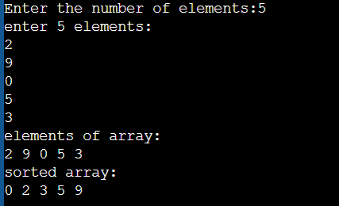

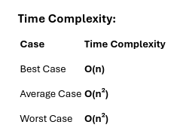

Conclusion:-
This practical helped me understand that every sorting algorithm is useful in different situations. Bubble Sort, Selection Sort, and Insertion Sort are easy to learn and good for small sets of data. Overall, this practical improved my knowledge of sorting techniques and helped me understand how to select the right algorithm based on the type and size of the data.

